ESP32S3 Driver / replace fix for windows 11

Get “Devices by driver view” by opening the Uninstall Menu Active
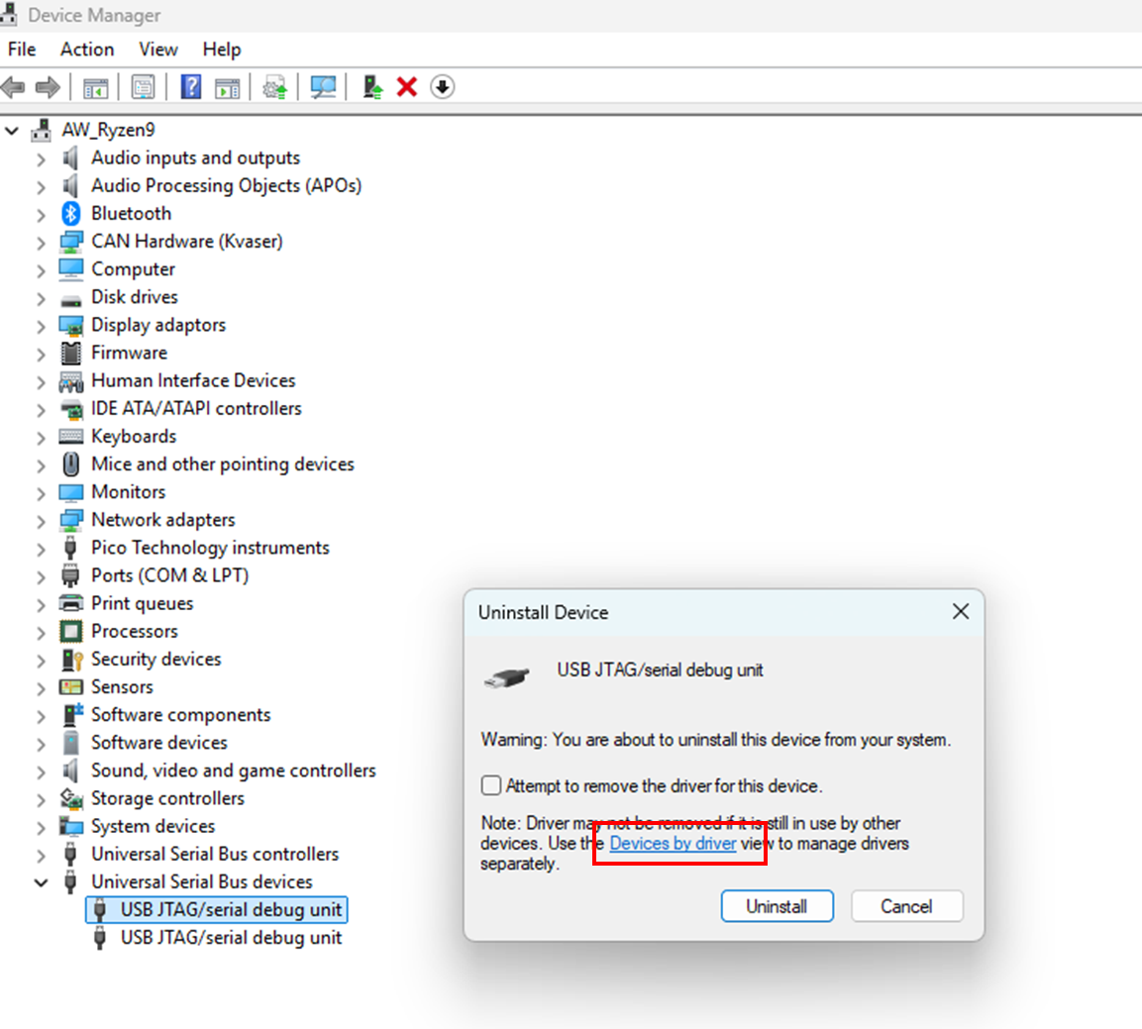

All the drivers are listed now
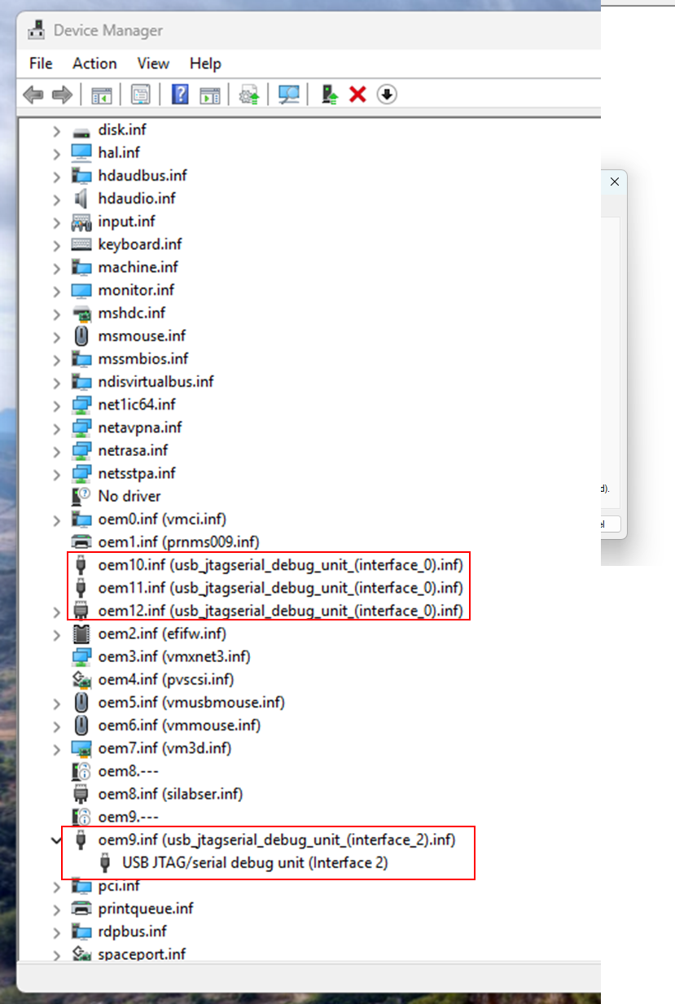

Go to the menu and enable “Show Hidden devices” AND REMOVE ALL jtag /serial drivers!

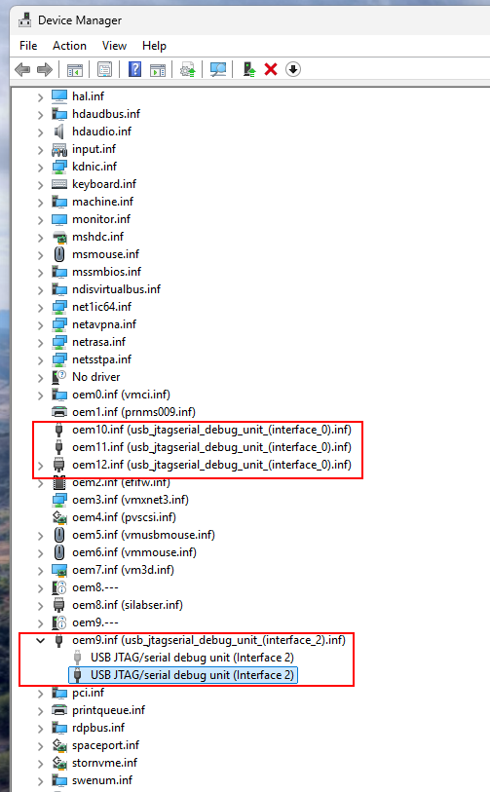

Now install https://dl.espressif.com/dl/idf-driver/idf-driver-esp32-usb-jtag-2021-07-15.zip for all active adaptors

